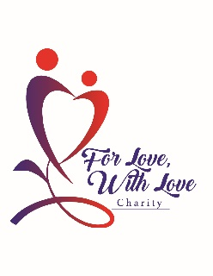
Driving for a Better Future

A New For Love With Love Program

Mission
Our program’s mission is to give young adults in Sandusky an opportunity to break the poverty cycle by helping them get a driver’s license. The lack of a driver’s license is a large barrier when seeking jobs. The ability to get to work in an area such as ours that has poor public transportation requires the ability to drive to that job. Many jobs require a license, such as equipment operators. The lack of a free driver’s education provided by the public-school system like it used to has become another separator between those who have and those who have not. The fee of approximately $350 for private driver’s education, a state requirement to get a license, is beyond the reach of many families who struggle to even buy food.
Program
Initially, we will give 10 grants per year for driver’s education fees to students of SHS. The students will be directed to the program by the Intern Coordinator’s office. The students will fill out an application. The application will be reviewed by For Love With Love and potential candidates interviewed personally by a board member. The first deadline will be February 15th, with additional deadlines the 15th of every month until the grants are gone. Successful candidates will be granted a voucher redeemable for class fees to a driver’s education school. For Love With Love will pay the school directly.
Additional Grants
For Love With Love is seeking donations for more licenses. The eventual goal will be to aid every student in the county who needs help getting their license.

